(1) Define the structure of a class ?
(A) -> Class is a blue print for how a data structure should function.
-> It is a building block of object oriented program.
-> Every class contains (a) Data
(b) Method
(c) Constructor
-> Data is the state of the class
-> Method is a task, which uses data to execute
-> Class isTemplate for an object

Structure of class:

Class <name>
{
int a;
int b;
main method()
{
------
------
}
}
-> Class name should start with capital letter
-> The method name starts with small letter and the consecutive words should Start with
capital letter.
-> The reason for naming the classes and method in such a way is that, in JAVA API files
followed the particular naming pattern

(2) What is the difference between class and object ?
(A) Class is the template for object.
Object is the physical form for the class
For example : (a)There are main objects in real time like pen table, board etc,..
(b)The Class contains data and methods. Data of the pen is its color, Dimensions, name and The method of the class is its uses(writing).

(3) Write a java program to find average marks of a student.
(A)

class Average
{
public static void main(String a[])
{
Marks k = new Marks();
k.averageOfMarks(100,90,70);
}
}

class Marks
{
int m1,m2,m3;
void averageOfMarks(int a,int b,int c)
{
double avg = (a+b+c)/3;
System.out.println("students marks average is = "+ avg);
}
}

OUTPUT :
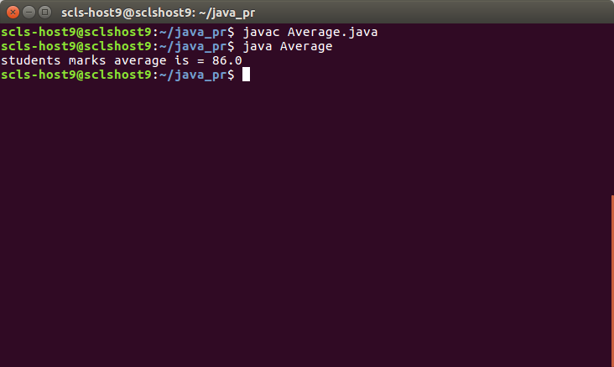
(4) Write a java program to find the big number in the given three numbers ?
(A)

public class LargestOf3
{
public static void main(String args[])
{
Numbers k = new Numbers();
k.calcLargest(10,30,20);
}
}

class Numbers
{
int a,b,c;
void calcLargest(int a,int b, int c)
{
if(a==b && b==c)
System.out.println(" All the three numbers are same");
else if(a==b && b>c)
System.out.println("Both a and b are largest numbers");
else if(a==c && c>b)
System.out.println("Both a and c are largest numbers");
else if(b==c && c>a)
System.out.println("Both b and c are largest number");
else if(a>b && a>c)
System.out.println("the a is largest number");
else if(b>a && b>c)
System.out.println("the b is largest number");
else if(c>a && c>b)
System.out.println("the c is largest number");

}
}

OUTPUT :

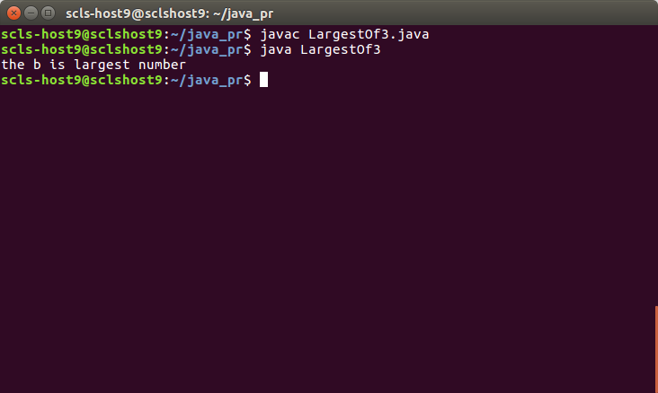

(5) Write a java program to print the details of an employee
(A)

public class Employee
{
public static void main(String args[])
{
EmployeeDetails k = new EmployeeDetails();
k.details();
}

}

class EmployeeDetails
{
String name = "Ravi";
int age = 6;
double salary = 444.55;
void details()
{
System.out.println("Employee Details");
System.out.println("Name is ravi");
System.out.println("age is 16");
System.out.println("Salary is 333.55");
}
}

OUTPUT :
